Lab: Docker Cluster (part 1)
Objective: | Understanding the basics of Docker and successfully execute basic entry-level exercises.
Successful Outcome: | You will have ran basic commands and task, and feel better prepared to begin working with Hadoop in Docker.
Before You Begin: | Open terminal up into your host machine.

Before we begin, here is a list of core Docker commands:
Docker Core Commands
build | Build an image from a Dockerfile
commit | Create a new image from a container's changes
exec | Run a command in a running container
images | List images
kill | Kill one or more running containers
login | Log in to a Docker registry.
port | List port mappings or a specific mapping for container
ps | List containers
restart | Restart a container
rm | Remove one or more containers
rmi | Remove one or more images
run | Run a command in a new container
top | Display the running processes of a container
FULL LIST | docs.docker.com/engine/reference/commandline/

Step 1. Let’s get started! Let’s start by downloading a new image, making some changes to that image, commit the changes, and then confirm our new image is in our local repository.

1.1. Let’s first grab an official Ubuntu image down, without using pull:

$ docker run -it ubuntu /bin/bash

Step 2. If successful you should find yourself logged into a new container as ‘root.’
Let’s now make the following changes, exit our container, and then verify changes
made.
NOTE: Notice that ‘$’ is used when outside the container, and ‘#’ when inside.

2.1. Let's first load our local apt repository with the code we need to install:
# sed -i ’s/us.archive.ubuntu.com/mirrors.163.com/' \
/etc/apt/sources.list

2.2. Now that's update our system and install Apache:
# apt-get update && apt-get install -y apache2

Step 3. Do NOT exit! But do open another terminal window once you’ve completed
the above step.

3.1. Now, let’s check to see if our container is running:

$ docker ps -l

3.2 Okay, now we can commit our changes, or 'save' or work:
$ docker commit <container id> apache2-example

Step 4. We should now be able to see our new image, created from our running
container, in our local repository.

4.1. Let's now check to see if our newly created and named images exist:

$ docker images

4.1. And, we can verify our container is still running:

$ docker ps

Step 5. Did you see it? If so, we can now spin up a new container, from our newly
created image, while still allowing our previous container to still run.

5.1. Do this by executing the 'run -it' command using the new image name:

$ docker run -it apache2-example bash

5.2. Now you can exit out of the container:
# exit

Step 6. Let's assign ports to our container by specifying them when we first launch our images with 'run' command. All specifications must be made when you launch. If we are successful we will be able to access our port via 'localhost' in our browser.
6.1. Launch a new container from our Apache image with these specifications:
$ docker run -p 25890:25890 -it apache2-example bash

6.2. Don't forget to start your Apache server up:
# service apache2 start

Step 7. We can now go and see if our work paid off. Hopefully we find a working introduction page in our localhost on the port we specified. Are you ready?
7.1. In your browser's address bar you'll want to type the following:
localhost:25890
NOTE: If you are working in a virtual environment and this doesn't work, find you're assigned ip address and use that instead of 'localhost'.

Great job! You have just run your first container, download and installed new components, commit-ed those changes, started up a server and verified it was working using your browser.

Lab: Docker Cluster (part 2)
Objective: | Learning more about Docker by setting up a developer environment with Hadoop 2.x and Ambari 2.x installed into Docker multiple containers.
Successful Outcome: | A standing Hadoop multi-node cluster, with Ambari running, all inside a specified number of Docker containers.
Before You Begin: | Open terminal up into your host machine.

Step 1. In this lesson we will setup a developer environment for running Hadoop 2.x in containers, using Docker 12. This is the lab environment you will use for the remained of the class.
1.1. Visit the following site and follow the instructions listed there:
https://github.com/Virtuant/hadoop2.x-cluster-docker12

Step 2. After you have complete the Github instructional you should have three individual containers, all using the network “hadoop,” and each running Hadoop 2.x.
2.1. We can confirm this by running a WordCount:
./run-wordcount.sh

Step 3. Confirm the results listed below:
***output***
input file1.txt:
Hello Hadoop
input file2.txt:
Hello Docker
wordcount output:
Docker 1
Hadoop 1
Hello 2

3.1. Once you have confirmed a successful WordCount job has completed, it's time to move on to the big stuff. We have three containers running now, all with Hadoop, but we do not have Ambari setup and configured to run.
3.2. Kill all three container and let's get started.
$ docker kill hadoop-master hadoop-slave1 hadoop-slave2

Step 4. Start-up our three containers again, using our script:
4.1. Run the script located inside hadoop2.x-cluster-docker12
$ ./start-container.sh
4.2. Now open up up two other windows for our 'hadoop-slave' 1 & 2:
$ docker exec -it hadoop-slave1 bash
$ docker exec -it hadoop-slave2 bash
So, you should have three windows open now: <root@hadoop-master> <root@hadoop-slave1> <root@hadoop-slave2>

Step 5. Let's verify a few things about our containers before beginning.
5.1. Type these commands in each host to verify their programs are installed:
# git
# nano
# ambari-server (Master Node Only)
# ambari-agent (All Nodes)
# ambari-metrics-assembly
# ntp
5.2. Before we launch, we need to do some networking in <etc/hosts> :
# nano /etc/hosts
Results should resemble, once finished:
127.0.0.1 localhost
::1 localhost ip6-localhost ip6-loopback
fe00::0 ip6-localnet
ff00::0 ip6-mcastprefix
ff02::1 ip6-allnodes
ff02::2 ip6-allrouters
172.18.0.2 hadoop-master
172.18.0.3 hadoop-slave1
172.18.0.4 hadoop-slave2

5.3. Before we launch, we need to do some networking in <etc/ambari- agent/conf/ambari-agent.ini> :
# nano /etc/ambari-agent/conf/ambari-agent.ini
Change ‘hostname’ to the MasterNode name, in our case “hadoop-master.”
Results should resemble:
[server]
hostname=”hadoop-master”
url_port=8440
secured_url_port=8441

5.4. Last step before we launch all our services; we need to setup Ambari's Server in our 'hadoop-master' node:
# ambari-server setup

Step 6. Let's launch!
6.1. First, let's get Hadoop back up and running by running our script:
# ./start-hadoop.sh
6.2. Next we will, fire up Ambari Server :
# ambari-server start
NOTE: Ambari-Server is only started in 'hadoop-master'
6.3. After Ambari Server, launch Ambari Agent:
# ambari-agent start
6.4. Now that Ambari Server and Ambari Agent are running, start NTP:
# service ntp start
Verify each service is running successfully by using the <status> command if you want. You are ready to move to the final stage of your environment setup.

Lab: Docker Cluster (part 3)
Objective: | Learning more about Docker by setting up a developer environment with Hadoop 2.x and Ambari 2.x installed into Docker multiple containers.
Successful Outcome: | A standing Hadoop multi-node cluster, with Ambari running, all inside a specified number of Docker containers.
Before You Begin: | Open terminal up into your host machine.

  - Start Firefox browser in the VM (4th icon from top):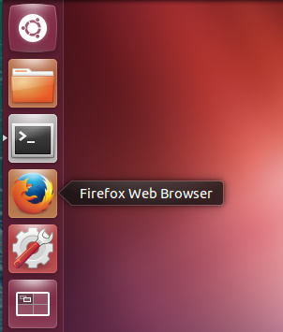
  - Navigate to following URL:http://localhost:8080
  - Log in to the Ambari server using the default credentials admin/admin:
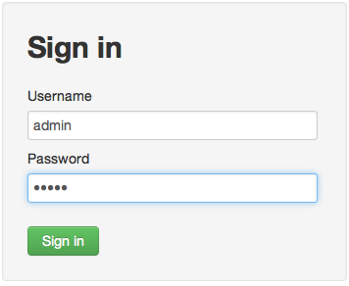

- Run the Install Wizard
  - At the Welcome page, enter the name “training” for your cluster and click the Next button.
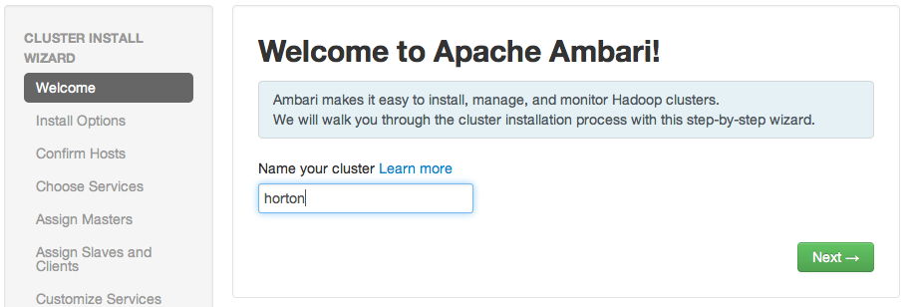

  - Select the service stack your instructor has specified.

- Under “Advanced Repository Options”, uncheck everything but your own OS. In our case this would be Ubuntu 14.
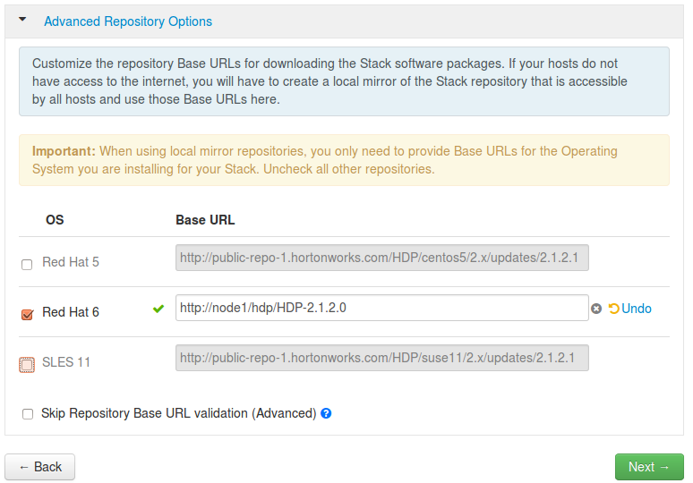
  - Click “Next” button

- Enter the Host and SSH Key Details
  - Enter hadoop-master, hadoop-slave1 and hadoop-slave2 in the list of Target Hosts.
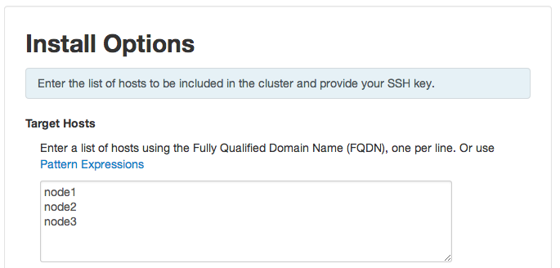
  - Just under the Host Registration Information section you will see an option to not enter a key but to install them manually

  - Click the Register and Confirm button. Click OK if you are warned about not using fully qualified domain names.

- Confirm Hosts
  - Once loading has finish, run the following in each node to clean the host:
python /usr/lib/python2.6/site-packages/ambari_agent/HostCleanup.py --silent --skip "users"
  - Now, rerun the host check-up to clear all possible warnings.
  - Once the process is done, click the Next button to proceed:
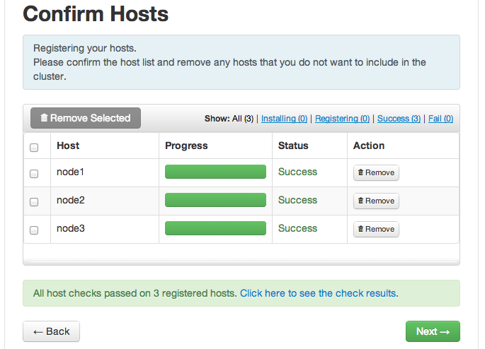

- Choose the Services to Install
  - Hortonworks Data Platform is made up of a number of components. You are going to install following services on your cluster initially (Uncheck HBase, Falcon & Storm, we will install them later):

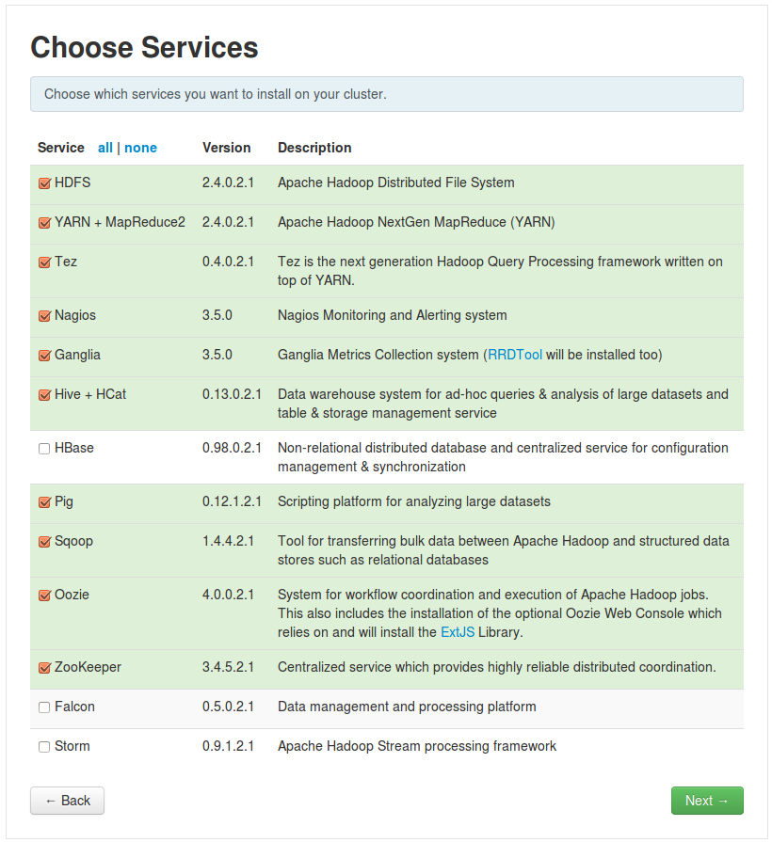

  - , Click the Next button:
- Assign Master Nodes
  - The Ambari wizard attempts to assign the various master services on appropriate hosts in your cluster. Carefully choose the following assignments of the master services.

  - Verify your assignments match the following:
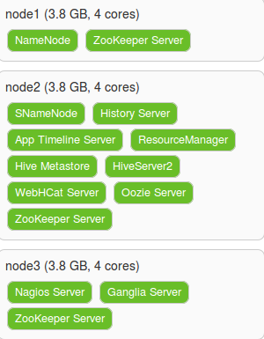
  - Click the Next button to continue.
- Assign Slaves and Clients
  - Assign all slave and client components to all nodes in the list:
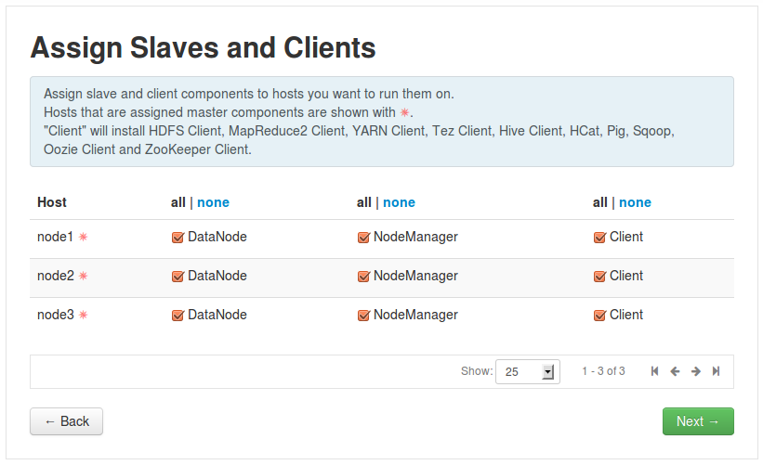
  - Click the Next button to continue.
- Customize Services
  - Notice three services require additional configuration: Hive, Oozie and Nagios. Click on the Hive tab, then enter hive for the Database Password:
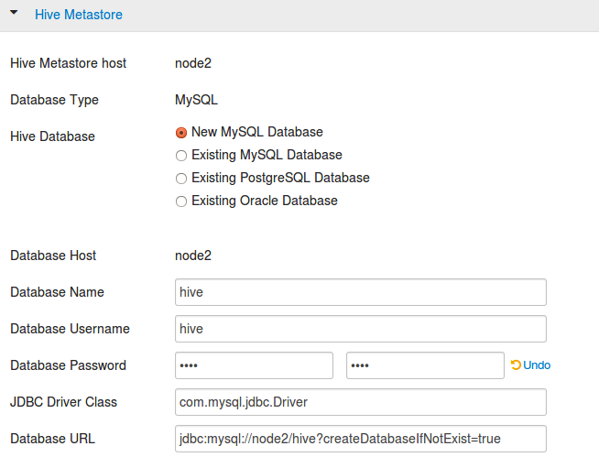

  - Click on the Oozie tab and enter oozie for its Database Password:
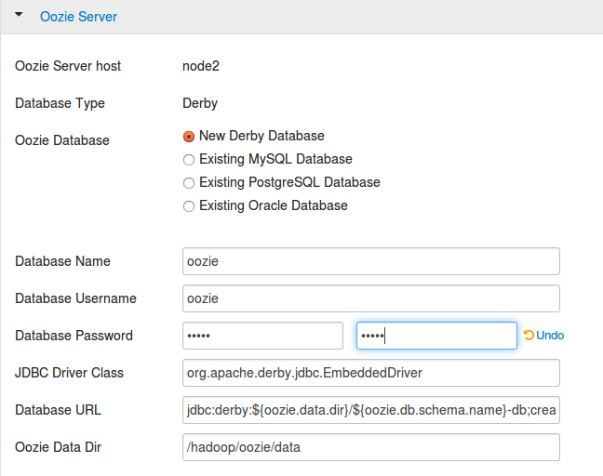
  - Click on the Nagios tab. Enter admin for the Nagios Admin password, and enter your email address in the Hadoop Admin email field:
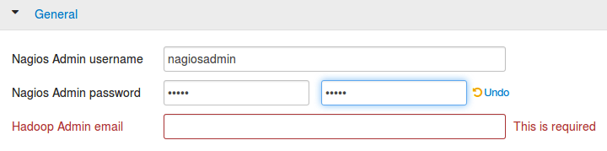
  - Click the Next button to continue.
- Review the Configuration
  - Notice the Review page allows you to review your complete install configuration. If you’re satisfied that everything is correct, click Deploy to start the installation process. (If you need to go back and make changes, you can use the Back button.)
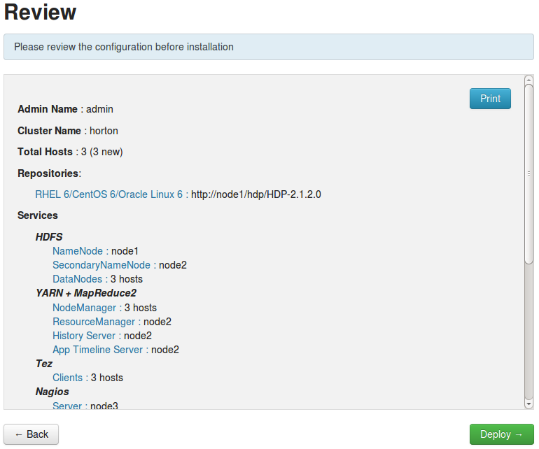
- Wait for HDP to Install
  - The installation will begin now. It will take up to 30 minutes to complete, depending on your computer processor and allocated RAM. You will see progress updates under the Status column as components are installed, tested, and started:
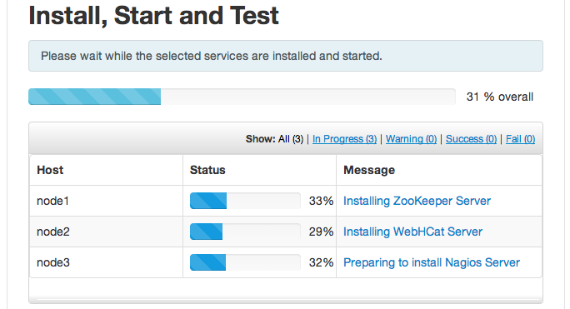
  - You should see the following screen if the installation completes successfully:
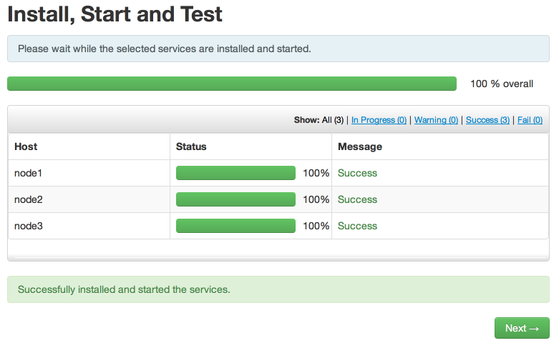
  - When the process completes, click Next to get a summary of the installation process. Check all configured services are on the expected nodes, then click Complete:
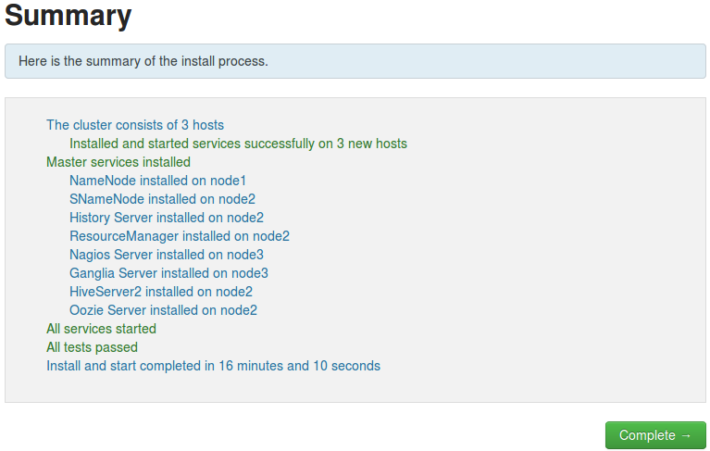
- View the Ambari Dashboard
  - After the install wizard completes, you will be directed to your cluster’s Ambari Dashboard page. Verify the DataNodes Live status shows 3/3:

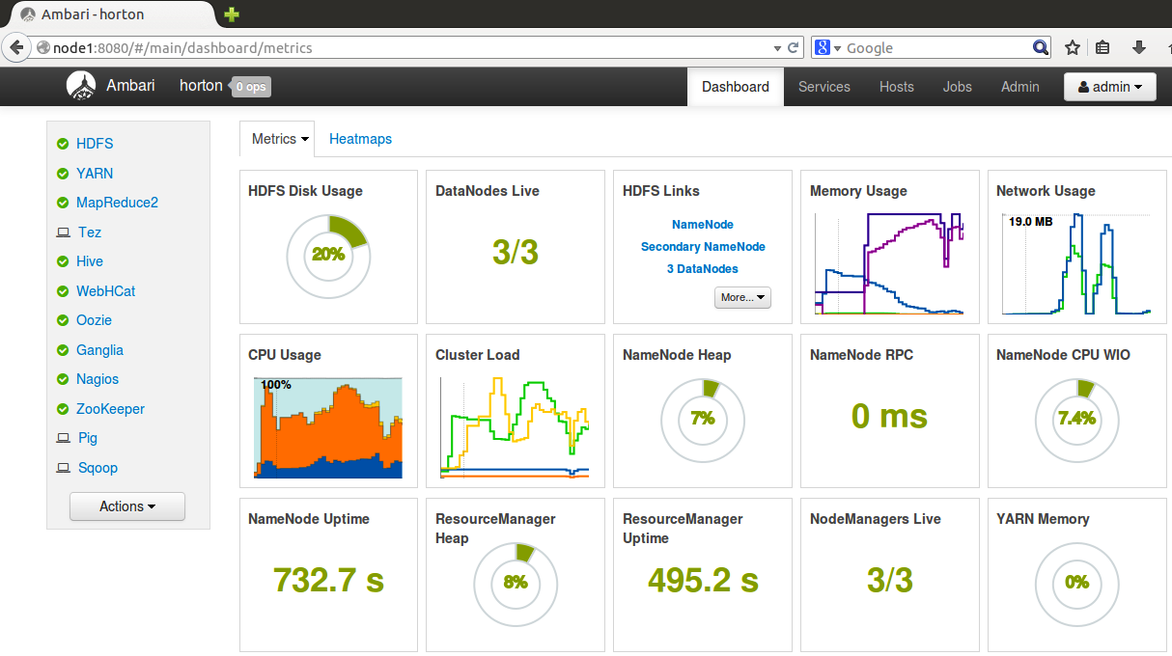
RESULT: You now have a running 3-node cluster of the Hortonworks Data Platform!

